OOPS
Assignment 2
Name-Aaditya Dawar
Roll No.-1024150093
Batch-2O13

Question 1-Write a program (WAP) to display "Hello World" on console display.
Code-
#include <iostream>
using namespace std;
int main() {
cout << "Hello World";
return 0;}
Output- 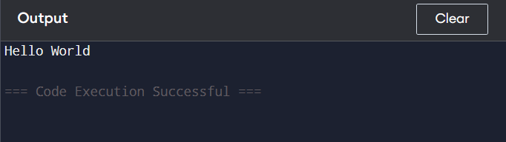

Question 2- WAP to input an integer, decimal and character and display it.
Code-
#include <iostream>
using namespace std;
int main() {
int i;
float d;
char c;

cout << "Enter an integer: ";
cin >> i;
cout << "Enter a decimal number: ";
cin >> d;
cout << "Enter a character: ";
cin >> c;
cout << "\nYou entered:\n";
cout << "Integer = " << i << endl;
cout << "Decimal = " << d << endl;
cout << "Character = " << c << endl;
return 0;
}
Output-
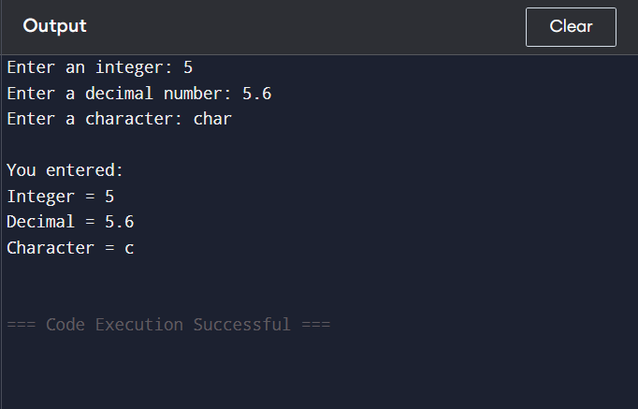
Question 3- WAP to add, subtract, multiply, divide numbers.
Code-
#include <iostream>
using namespace std;

int main() {
float a, b;
cout << "Enter two numbers: ";
cin >> a >> b;
cout << "Addition = " << a + b << endl;
cout << "Subtraction = " << a - b << endl;
cout << "Multiplication = " << a * b << endl;
if (b != 0)
cout << "Division = " << a / b << endl;
else
cout << "Division not possible (division by zero)" << endl;
return 0;
}
Output- 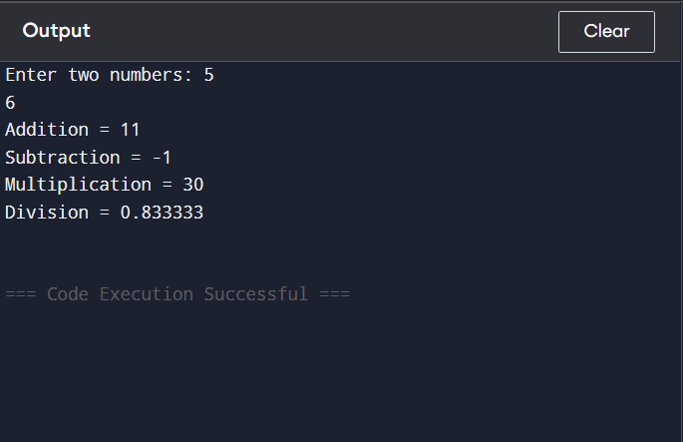
Question 4- Write a C++ program that will ask for a temperature in Celsius and display it in degree Fahrenheit.[F=9C/5+32]
Code-
#include <iostream>
using namespace std;
int main() {
float celsius, fahrenheit;
cout << "Enter temperature in Celsius: ";
cin >> celsius;
fahrenheit = (9 * celsius) / 5 + 32;
cout << "Temperature in Fahrenheit = " << fahrenheit << endl;
return 0;
}
Output- 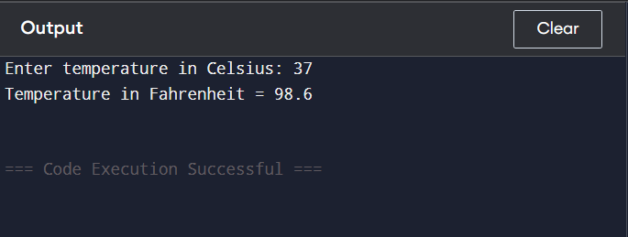
Question 5- WAP to format console output using '\n', '\t', '\b' , endl, setw within cout statement
Code-
#include <iostream>
#include <iomanip>
using namespace std;
int main() {
cout << "Using newline (\\n):\n";
cout << "Hello\nWorld\n\n";

cout << "Using tab (\\t):\n";
cout << "Name\tAge\tMarks\n";
cout << "Aaditya\t20\t95\n\n";
cout << "Using backspace (\\b):\n";
cout << "HelloX\b World\n\n";
cout << "Using endl:\n";
cout << "Line one" << endl;
cout << "Line two" << endl << endl;
cout << "Using setw:\n";
cout << setw(10) << "Name"
<< setw(10) << "Age"
<< setw(10) << "Marks" << endl;
cout << setw(10) << "Aaditya"
<< setw(10) << 20
<< setw(10) << 95 << endl;
return 0;
}
Output- 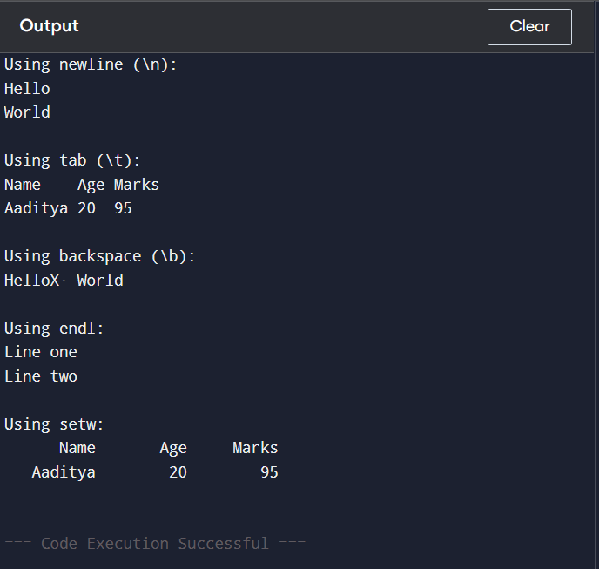
Question 6- WAP to utilize assignment += and - = type operators.
Code-
#include <iostream>
using namespace std;
int main() {
int a;
cout << "Enter a number: ";
cin >> a;
a += 5; // a = a + 5
cout << "After a += 5, value = " << a << endl;

a -= 3; // a = a - 3
cout << "After a -= 3, value = " << a << endl;
return 0;
}
Output- 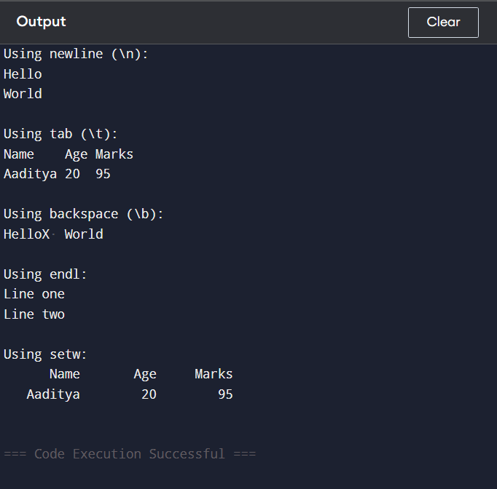
Question 7- WAP to swap two numbers using bitwise operator.
Code-
#include <iostream>
using namespace std;
int main() {
int a, b;
cout << "Enter two numbers: ";
cin >> a >> b;
// Swapping using XOR
a = a ^ b;
b = a ^ b;
a = a ^ b;
cout << "After swapping:" << endl;
cout << "a = " << a << endl;
cout << "b = " << b << endl;
return 0;
}
Output- 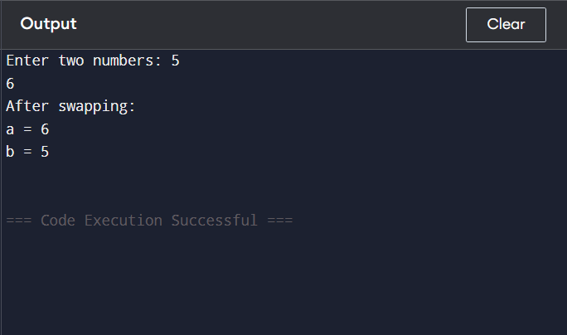
Question 8- Write a program to solve the following problem
A library charges a fine for every book return late. For first 5 days the fine is 50 paise, for 6-10 days fine is one rupee and above 10 days fine is 5 rupees. If you return the book after 30 days your membership will be cancelled .WAP to accept no. of days the member is late to return the book and display the fine or appropriate message.
Code-
#include <iostream>
using namespace std;
int main() {
int days;
float fine = 0;
cout << "Enter number of days late: ";
cin >> days;
if (days <= 5 && days > 0) {
fine = days * 0.50; // 50 paise per day
cout << "Fine = Rs. " << fine << endl;
}
else if (days <= 10) {
fine = days * 1.0; // 1 rupee per day
cout << "Fine = Rs. " << fine << endl;
}
else if (days <= 30) {
fine = days * 5.0; // 5 rupees per day
cout << "Fine = Rs. " << fine << endl;
}
else {
cout << "Membership cancelled!" << endl;
}
return 0;
}
Output- 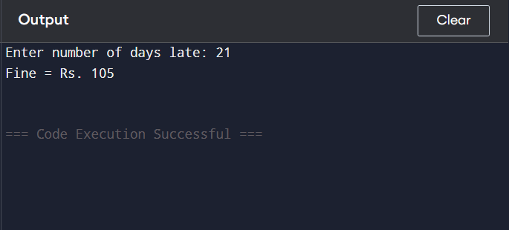
Question 9- WAP to display arithmetic operations using switch-case statement.
Code-
#include <iostream>
using namespace std;
int main() {
int a, b;
char op;
cout << "Enter two numbers: ";
cin >> a >> b;
cout << "Enter operator (+, -, *, /): ";
cin >> op;
switch (op) {
case '+':
cout << "Addition = " << a + b << endl;
break;
case '-':
cout << "Subtraction = " << a - b << endl;
break;
case '*':
cout << "Multiplication = " << a * b << endl;
break;
case '/':
if (b != 0)
cout << "Division = " << a / b << endl;
else
cout << "Division not possible" << endl;
break;
default:
cout << "Invalid operator!" << endl;
}
return 0;
}
Output- 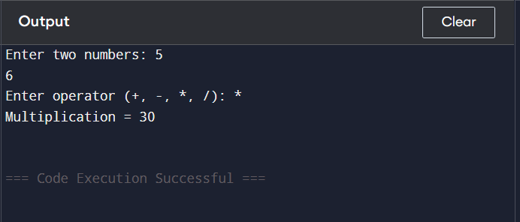
Question 10- WAP to check whether the given number is even or odd (By using if-else and conditional operator).
Code-
#include <iostream>
using namespace std;

int main() {
int num;
cout << "Enter a number: ";
cin >> num;
// Using if-else
if (num % 2 == 0)
cout << "Using if-else: Number is Even" << endl;
else
cout << "Using if-else: Number is Odd" << endl;
(num % 2 == 0) ?
cout << "Using conditional operator: Number is Even" << endl :
cout << "Using conditional operator: Number is Odd" << endl;
return 0;
}
Output- 